Unit Overview
Week | 1 | 2 | 3 | 4
1 | 1.1 PL/Public holiday | 1.2 Recap T1 test skills | 1.3 Recap T1 test skills | 1.4 Catch up assessment
2 | 2.1  L.G: We will learn about why Australia had a constitution.  C.S: Glossary has all new key terminology neatly added.  Able to explain why a country has a set of rules.  Introduction to Civics and Citizenship  Explain the two key focus questions of the term:  - How is Australia’s system of democratic government shaped by the Constitution?  - What principles of justice help to protect the individual’s rights to justice in Australia’s system of law?  Outline assessments over the term.  KWL/Brainstorm/graphic organiser  Key terminology:  - Government  - Democracy  - Constitution  - Fundamental  - Principles  - Precedent  - The Executive  - Houses of parliament  - Bicameral  - Division of powers  - Referendum  Literacy task  Introduction to the constitution as a set of rules for a country. | 2.2  L.G: We will learn about the key features of the Australian Constitution  C.S: We will make a mini book showing a summary of the eight chapters in the Australian Constitution  What is the constitution?  -concept map  The Australian Constitution  Snapshots- federation 2.39 mins  http://www.peo.gov.au/multimedia/videos/snapshots-federation.html  Snapshots- Constitution 2.29 mins  http://www.peo.gov.au/multimedia/videos/the-constitution.html  - Students to write focus questions prior to watching clips  How Australia formed its Constitution  Get Parliament document  - Federation pp. 2-3  - Constitution pp. 4-5  Key terminology:  Federation | 2.3  L.G: We will learn about how Australia can change its constitution.  C.S: 1-We will be able to explain what a referendum is  2-We will run a referendum in class and count the results  Hand out homework task  Changing the constitution  PEO The Australian Constitution closer look fact sheet  Referendums  What is a referendum?  How and why are they run?  What is the difference between a plebiscite and a referendum?  Foldable activity if time permits – DIY constitution | 2.4 In Class Short Answer Responses:
3 | 3.1  L.G: We will learn about what the Westminster System is and it key features.  C.S:  Westminster system  Where did it originate?  Why does Australia use it?  Key features  Key terminology:  - Westminster system  - Responsible government  - Bicameral  - Unicameral | 3.2  L.G: We will learn about why we have a ‘Separation of Powers’ and what each branch does.  C.S: Complete graphic organiser  Separation of powers  What is the Judiciary?  What is the Legislative/Parliament?  What is the Executive?  Why is the power of our government split into three branches?  Separation of powers – what it looks like chart  Key terminology:  - The Judiciary  - The Legislative  - The Executive | 3.3  L.G: We will learn about why we have a ‘Separation of Powers’ and what each branch does.  C.S: Able to recall the names and the purpose for each branch  Able to withdraw information about the Separation of Powers from a text.  Separation of powers  Rolia information withdrawal task | 3.4 Collect Assessment 7 – Homework Inquiry  Validation test on Homework Inquiry task.  Separation of powers
4 | 4.1  L.G: Research key information for the inquiry assessment  C.S: using time wisely in class to research  Information put into booklets  Bibliography sheet being used  Inquiry task computer lab | 4.2  L.G: We will learn about why there are three levels of government and the names of each level.  C.S: write questions to ask guest speaker about the three levels of government  Three levels of government  What are the three levels of government?  What are the key responsibilities of each level of government card sort  Students to complete card sort then check answers as group and put each responsibility into a chart | 4.3  L.G: Research key information for the inquiry assessment  C.S: using time wisely in class to research  Information put into booklets  Bibliography sheet being used  Inquiry task computer lab | 4.4  L.G: We will actively listen to a talk from a member of Local/State government.  C.S: Respectful listening and asking appropriate questions  Incursion Local Govt./State Govt.  Aaron Cook?
5 | 5.1  L.G: We will learn about the different responsibilities each level of government has.  C.S: Complete card sort activity  Explain the responsibilities of 1 level in a short answer  Three levels of government  Card Sort | 5.2  L.G: We will apply our knowledge on the Three Levels of Government and Government in Australia  C.S: Take notes to use when participating in a quiz  Participate in quiz.  Three levels of Government  Constitution Centre Three levels of Government information and Quiz activity | 5.3 Collect Assessment 9- inquiry task (poster/Brochure)  L.G: We will learn what the Senate is including origins and role  C.S: Withdrawing key information  Using a graphic organiser  Use key information to answer questions  The Senate  Economics Civics and Citizenship page 271-272 | 5.4  L.G: We will learn what the House of Representatives is including origins and role  C.S: Withdrawing key information  Using a graphic organiser  Use key information to answer questions  House of Representatives  Link to the House of Commons (why should The People be represented in Parliament link to Westminster)  Economics Civics and Citizenship page 272-273
6 | 6.1  L.G: We will compare and contrast the different Houses of our bicameral Parliament.  C.S: Label the Houses  Complete a Venn Diagram  Compare contrast The Senate and the House of representatives  Label the Houses  Complete a Venn Diagram | 6.2  L.G: We will understand the process of how Parliament makes laws.  C.S: We will complete a flowchart showing the eight steps of how a bill becomes law.  Making laws  Flowchart  Optional – PEO Flow chart of the process of making laws | 6.3  L.G: We will learn about the difference between Civil and Criminal law.  C.S:  Types of laws  Glossary  - Civil Law  - Criminal Law  Students given a list of examples of examples of crimes/disputes to sort into Civil or Criminal  Make Card Sort | 6.4  L.G: We will learn what the role of a Court Room is and what happens in a Court Room.  C.S: Completed court hierarchy with examples of what types of cases are disputed in each court  What happens in a court room  Where are different types of courts? (locations)  What types of cases are disputed in each court  Court hierarchy pyramid
7 | 7.1  L.G:  C.S:  Who’s who in a court room  National Trust 3D courtroom  Students work with computers | 7.2  L.G:  C.S:  Court case in class | 7.3  L.G:  C.S:  Presumption of innocence  Burden of proof | 7.4 Assessment 10
8 | 8.1  L.G:  C.S:  Symbols of justice (Lady Justice’s blindfold, sword, scales etc.)  Perceptions of others and why the symbols of justice are important | 8.2  L.G:  C.S:  What is a fair trial? | 8.3  L.G:  C.S:  What is a fair trial? | 8.4  L.G:  C.S:  Australians access to justice and legal representation
9 | 9.1  L.G:  C.S:  Debate skills | 9.2  L.G:  C.S:  DEBATE | 9.3  L.G:  C.S:  DEBATE | 9.4  L.G:  C.S:  DEBATE
10 | 10.1  L.G:  C.S:  Debate – liveability + rights and responsibilities | 10.2  L.G:  C.S:  DEBATE | 10.3  L.G:  C.S:  DEBATE | 10.4  L.G:  C.S:  DEBATE

Appendix

2.1
Term | Definition
Government | The group of people with the authority to govern a country or state.
Democracy | A system of government where the population of a country is governed by a group of elected representatives.
Constitution | A body of fundamental principles or established precedents used to govern a country.
Fundamental | Absolutely necessary, important.
Principles | Rule and laws.
Precedent | An earlier law that is used as an example for how to deal with future similar situations.
The Executive | The branch of a government responsible for putting decisions or laws into effect.
Houses of parliament | The Upper House (The Senate), and the Lower House (The House of Representatives).
Bicameral | When there are two houses of parliament.
Division of powers | The Separation of Powers goes into three branches. Legislative makes laws, the Executive carries out the laws, and the Judiciary interprets the laws. The Legislative and Executive branches are joined in Australia.
Referendum | A vote by the people on a single political question.

2.2
Term | Definition
Federation | When the states of Australia joined together to make a nation in 1901.

Focus questions - Students to write down prior to watching video clips

- Why did the people in Australian colonies want to join together to form a nation?
- Why was the Constitution written?
- What happened in 1901?
Snapshots- federation 2.39 mins
http://www.peo.gov.au/multimedia/videos/snapshots-federation.html
Snapshots- Constitution 2.29 mins
http://www.peo.gov.au/multimedia/videos/the-constitution.html

Get Parliament Document - http://www.peo.gov.au/uploads/peo/docs/resources/PEO_get_parliament_web.pdf
http://www.peo.gov.au/uploads/peo/docs/closer-look/CloserLook_Constitution.pdf
http://www.aph.gov.au/About_Parliament/House_of_Representatives/Powers_practice_and_procedure/00_-_Infosheets/Infosheet_13_-_The_Constitution
Concept Map Document - http://www.peo.gov.au/uploads/peo/docs/units-of-work/PEO_UOW_Year-7_Concept-Map.pdf

2.3
PEO The Australian Constitution closer look fact sheet
http://www.peo.gov.au/uploads/peo/docs/closer-look/CloserLook_Constitution.pdf
http://www.peo.gov.au/learning/fact-sheets/referendums-and-plebiscites.html

Constitutional referendums
The Australian Constitution can only be amended with the approval of Australian voters. Therefore, any proposed alteration must be put to the vote at a referendum.
Section 128 of the Constitution provides that any proposed amendment to the Constitution must be passed by an absolute majority in both Houses of the Commonwealth Parliament.
In certain circumstances, a proposed amendment can be submitted to a referendum if it is passed on two separate occasions by only one House of the Parliament.
At the referendum the proposed alteration must be approved by a 'double majority'. That is:
- a national majority of voters in the states and territories
- a majority of voters in a majority of the states (i.e. at least four out of six states).
Since Federation, only eight out of 44 proposals to amend the Constitution have been approved (see Referendum dates and results).
Voting in referendums is compulsory for enrolled voters. In referendums, voters are required to write either 'yes' or 'no' on the ballot paper in response to each question listed.
Rules governing referendums are included in the Referendum (Machinery Provisions) Act 1984.

How a Constitutional referendum works
A referendum must be held no sooner than two and no later than six months after the proposal is passed by Parliament. The main stages are:
- A Bill is passed by Parliament
A Bill setting out the proposed alteration to the Constitution is passed by both Houses of Parliament. If the Bill is passed by one House but rejected, or altered, in the other (and the alterations are unacceptable to the first House) and this is repeated in the next session of the Parliament, the Governor-General may put the proposal to voters as last proposed by the first House with or without any amendments agreed by both Houses.
- Case committees are formed
A majority of the Members of the House of Representatives and Senators who voted for the proposal and a majority of those who voted against it are divided into the 'Yes committee' and the 'No committee' for the referendum. These committees are responsible for a range of activities supporting a vote for or against the proposed alteration to the Constitution. When a proposal is passed unanimously by Parliament, a 'No' committee is not formed.
- A Writ is issued
The Governor-General issues the Writ for the referendum. The date set for the close of rolls is seven days after the issue of the writ; and polling day, which must be on a Saturday, is not less than 33 days or more than 58 days after the issue of the writ.
- Information is provided to voters
In the four weeks after the passage of the Bill, the committees are required to prepare a 'case' for voting 'Yes' and a 'case' for voting 'No'. These cases are lodged with the Electoral Commissioner, and are printed together with a statement showing the proposed alterations. This must be posted to every voter on the electoral roll, as nearly as practicable no later than 14 days before polling day.

- Australians vote
Voting in a referendum is similar to casting a vote in the federal election. Polling places are established in all federal divisions, and polling day is always a Saturday. The key difference is what voters are required to write on their referendum ballot paper. In a referendum, voters are required to write either 'Yes' or 'No' in the box opposite each question on the ballot paper. If the referendum is carried, the proposed law is given Royal Assent by the Governor-General.

Plebiscites
An issue put to the vote which does not affect the Constitution is called a plebiscite. A plebiscite is not defined in the Australian Constitution, the Electoral Act or the Referendum Act. A plebiscite can also be referred to as a simple national vote.
Governments can hold plebiscites to test whether people either support or oppose a proposed action on an issue. The government is not bound by the 'result' of a plebiscite as it is by the result of a Constitutional referendum. Federal, state and territory governments have held plebiscites on various issues.
Under s. 7A of the Electoral Act, the AEC can conduct a plebiscite as a fee-for-service election, with the AEC entering into 'an agreement, on behalf of the Commonwealth, for the supply of goods or services to a person or body'. The rules for a plebiscite or fee-for-service election are normally contained in the terms of the agreement between the AEC and the person funding the election.
Military service plebiscites were held in 1916 and 1917 but, as they were not proposals to amend the Constitution, the provisions of section 128 of the Constitution did not apply. Voters in all federal territories were permitted to vote. Both the military service plebiscites sought a mandate for conscription and were defeated

3.1
Term | Definition
Westminster System | A system of Parliament which is based off of the system of government in Great Britain.
Responsible government | When a government is accountable for its actions to Parliament.
Bicameral | When there are two Houses or Chambers of parliament such as the Senate and the House of Representatives
Unicameral | When there is only one House or Chamber of parliament such as in Queensland, the Northern Territory and the Australian Capital Territory.

The Westminster System
The Westminster system gets its name from the area in central London where the Parliament of the United Kingdom is located. The Westminster system is a democratic system and is used in countries such as Britain, Canada, New Zealand as well as in many parts of the Pacific, Asia and Africa. The federal and state levels of government, which operate in Australia, are also based on the Westminster system.

Separation of powers
The separation of powers is the division of responsibilities and powers into three separate branches:
- legislature or the parliament, which is responsible for making laws;
- the executive or government, which is responsible for administering laws and delivering government services; and
- the judiciary or the courts, which interpret how the law is to be applied.

Key features
Other key features of the Westminster system are:
- Democratic elections—there are democratic elections and the party that is able to secure the support of a majority of members in the lower house is able to form government. To stay in office, the government must keep this majority.
- Leader of the government—the government is able to elect a leader.
- At the national level, the leader of the government is the Prime Minister. In the states the leader is the Premier. In the ACT and the Northern Territory, the leader is the Chief Minister.
- In the ACT, the Assembly is responsible for electing the leader (the Chief Minister) whereas in the Commonwealth and the other states and territories, the party in government is responsible for electing the leader.
- The leader chooses a group of ministers, also called the cabinet or the executive, which is accountable to the parliament.
- Opposition—there is a formal opposition, led by the leader of the party or parties with the second largest number of seats in the lower house or Assembly. One of the jobs of the opposition is to hold the government accountable in the parliament.
- the Crown—where there is a constitutional monarch or ‘Crown’, their role is not political—the King or Queen is to act on the advice of the Prime Minister. This principle also applies to representatives of the Crown. The ACT does not have a representative of the Crown in its constitutional arrangements. Other jurisdictions have a Governor-General (Commonwealth), Governor (States) or Administrator (Northern Territory) to provide ‘assent’ to laws that have been passed by parliaments.
- Independent public service—there is a career public service that is impartial and serves the government of the day.
- Rule of law—the rule of law prevails, with an independent judiciary, subject to the Constitution.

Westminster Variations
The Westminster system varies from country to country, depending on local conditions and history.
For example, Britain has a second chamber of Parliament, known as the House of Lords, whose members are either hereditary Lords or Lords appointed for life. The Blair Labour Government instituted reforms to the system of appointment, notably abolishing further hereditary positions.
By contrast, Australia has a second chamber of Parliament, known as the Senate, whose members represent the States of the Commonwealth, in fulfillment of the concept of federalism.
New Zealand, however, has a unicameral, or single-chamber, Parliament. Queensland, the Northern Territory and the Australian Capital Territory also have unicameral parliaments.
All these variations follow the principles of the Westminster system, in that governments are derived from the popularly-elected lower house.
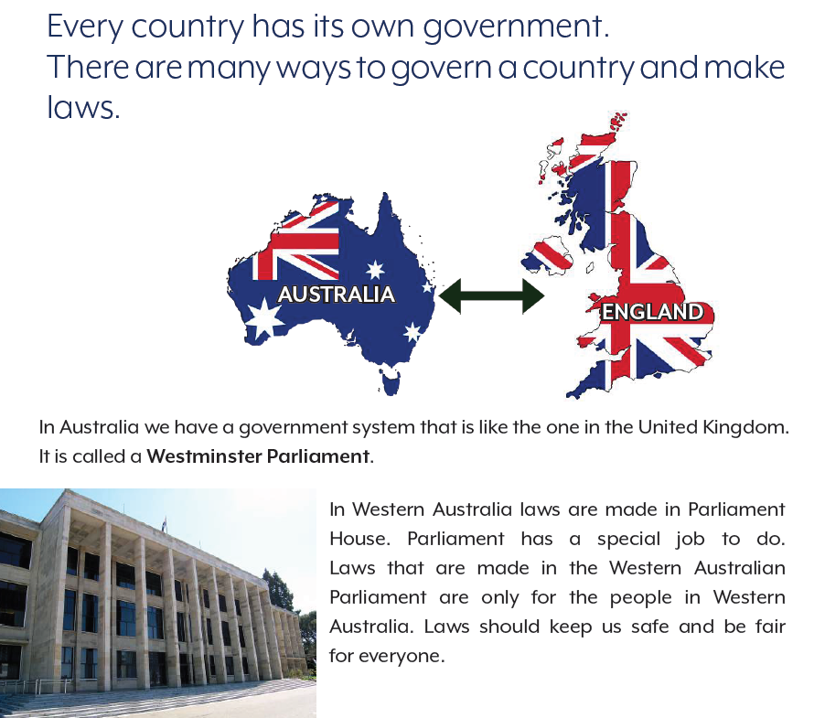

3.2
http://www.peo.gov.au/uploads/peo/docs/fact-sheets/separation_powers.pdf
Term | Definition
The Legislature | Another name for Australia’s Parliament, the part of our government which makes laws.
Executive | A group of ministers who use the powers in the laws to run the country.
Judiciary | The court system which interprets and applies the laws made by the Legislature.
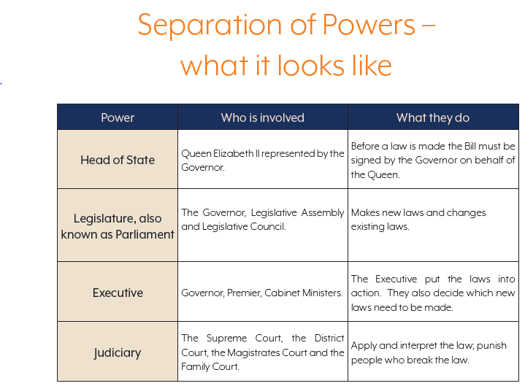
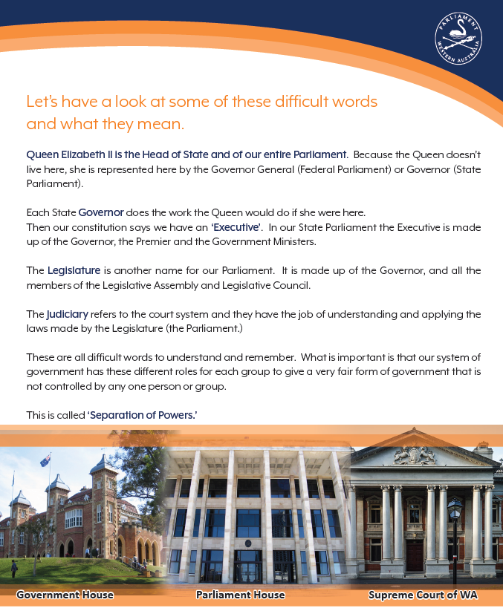

3.3
http://www.ruleoflaw.org.au/wp-content/uploads/2016/07/2016-07-18_Rule_of_Law_Institute_Separation_of_Powers_Poster.pdf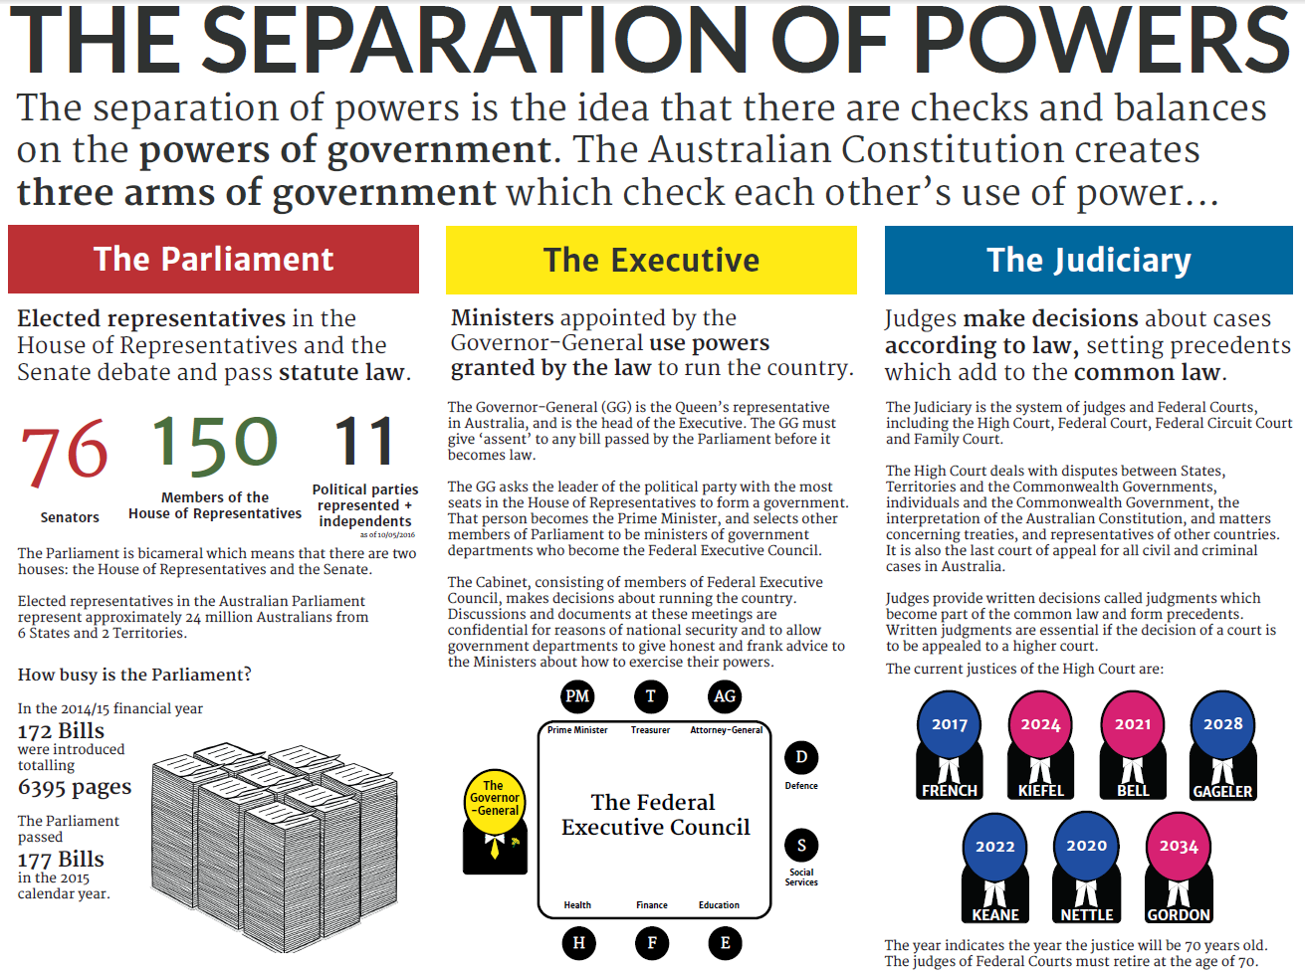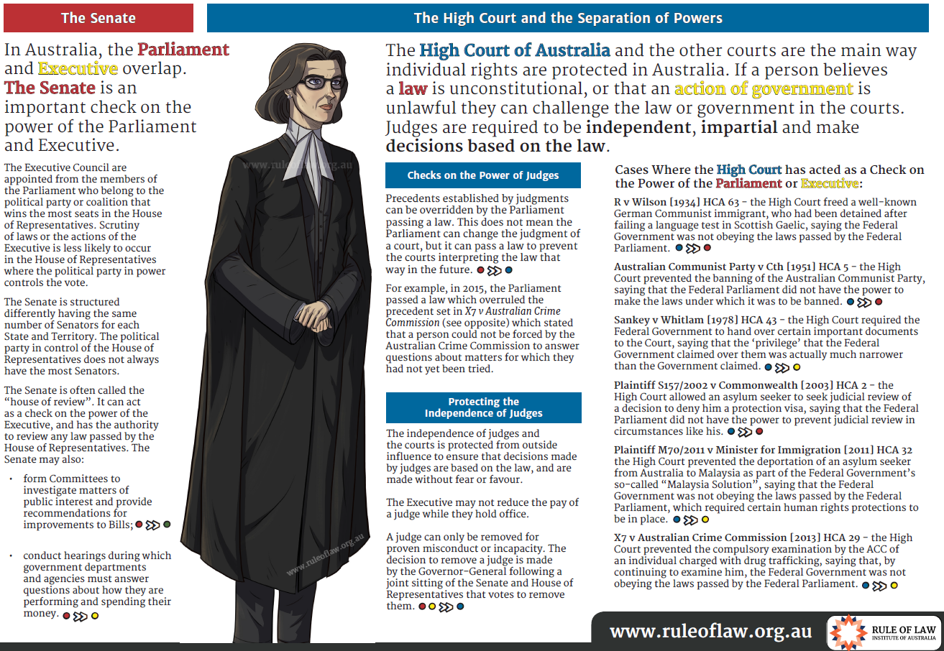

3.4

4.1

4.2

4.3

4.4

5.1

5.2

5.3

5.4

6.1

6.2

6.3

6.4
https://www.lawsocietywa.asn.au/wp-content/uploads/2015/10/2017JAN-Year-9-Student-FBLEP-Pre-Visit-Resource.pdf

7.1

7.2

7.3
http://www.ruleoflaw.org.au/education/videos/innocence/

The Role of a Prosecutor 00:00
Mark Tedeschi QC discusses the dual roles and responsibilities of a prosecutor.
1. To ensure justice is done for the accused.
“As a prosecutor you are there to see that justice is done, not to get a conviction at all costs.”
“A prosecutor is there, like a judge, to see that justice is done”
2. To ensure justice is done for the community.
“The prosecutor has an obligation representing the community.”
“You are there as a minister of justice … to ensure the accused gets a fair trial, but you are also there to make sure that the community gets a fair trial.”

How have the duties of a prosecutor changed over time? 01:39
Mark Tedeschi QC discusses the changing obligations surrounding the disclosure of facts and evidence.
“By the time of the trial the accused is entitled to know everything that is relevant to the case.”
“[The] duty of disclosure has become heightened.”

What is the prosecutors main role when speaking to the court? 02:50
Mark Tedeschi QC discusses the importance of making proceedings understandable to the jury. He says that the most important role of a prosecutor is “to explain legal concepts to jurors in a way that they will understand.”

What is the presumption of innocence? 03:35
Mark Tedeschi QC discusses the definition of the presumption of innocence. He says the presumption of innocence means … “that the prosecution brings the charge against the accused, and for that reason the prosecution has the burden of proving that charge. The standard of proof required is proof beyond reasonable doubt…”

What is the standard of proof? 04:15
Mark Tedeschi QC then discusses why it is difficult for juries to define ‘beyond reasonable doubt’ and the difference between mathematical certainty and ‘beyond reasonable doubt’.

7.4

8.1

8.2

8.3

8.4
http://www.ruleoflaw.org.au/guide/index.html This website is great for a web quest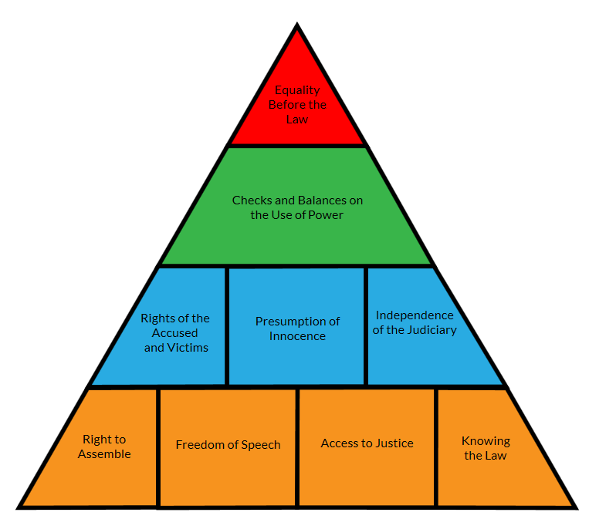 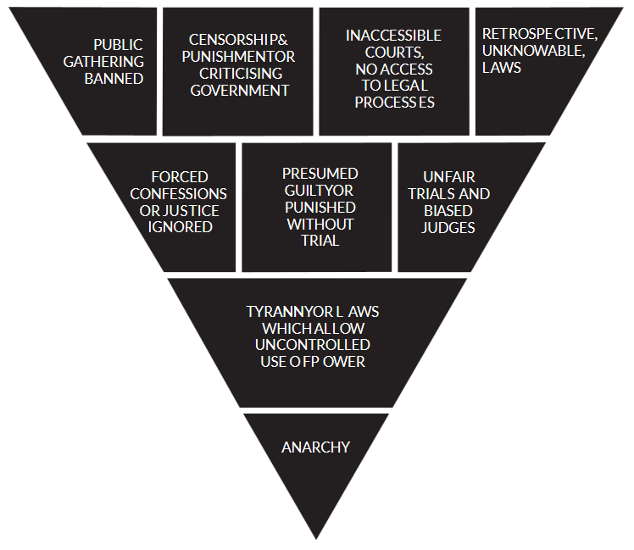

9.1

9.2

9.3

9.4

10.1

10.2

10.3

10.4

Additional activities
- Eight key people involved forming Australia’s Constitution
- Rule of Law PDF http://www.ruleoflaw.org.au/wp-content/uploads/2016/04/Rule_of_Law_Institute_The-Rule-of-Law-Principle-in-Australia.pdf

Civics & Citizenship Explanation  (Test) | 10% | Term 2, Week 2 | Assessment 6: In-Class Short Answer Responses: A series of questions related to topics such as the Australian Constitution, the concept of the separation of powers – legislature, executive and judiciary, plus the division of powers between state/territory and federal levels of government in Australia.
Civics & Citizenship Inquiry  (Written Work) | 10% | Set: Term 2, Week 2  Due: Term 2, Week 3 | Assessment 7: Homework Inquiry Task: Students research and compile relevant information related to Australia’s system of government, particularly in relation to the different roles of the House of Representatives and the Senate (Australia’s bicameral parliament)
Civics & Citizenship Explanation  (Test) | 5% | Term 2, Week 4 | Assessment 8: Homework Inquiry Task Validation: Students answer a series of questions based on the Homework Inquiry Task (Assessment 7)
Civics & Citizenship Inquiry  (Visual Representations) | 15% | Hand out Week 1, Term 2  Term 2, Week 5 | Assessment 9: Inquiry Task (Poster and/or Brochure)– Australia’s Legal System – such as rule of law, presumption of innocence, burden of proof, right to a fair trial and right to legal representation.
Civics & Citizenship Explanation  (Test) | 10% | Term 2, Week 6/7 | Assessment 10: In-Class Short Answer Responses: Final Test  A series of questions related to topics such as Australian Constitution, separation of powers, division of powers, House of Representatives and Senate, constitutional change, Australia’s legal system, citizen participation (role of witness and jurors)

